Package proteoQ

2019-09-21

Table of Contents

## Introduction to proteoQ

Chemical labeling using tandem mass tag ([TMT](https://en.wikipedia.org/wiki/Tandem_mass_tag)) has been commonly applied in mass spectrometry (MS)-based quantification of proteins and peptides. The proteoQ tool is designed for automated and reproducible analysis of proteomics data. It interacts with an Excel spread sheet for dynamic sample selections, aesthetics controls and statistical modelings. It further integrates the utilities of data filtration and ordering into functions at the users’ interface. The arrangements allow users to put *ad hoc* manipulation of data behind the scene and instead apply metadata to openly address biological questions using various informatic tools. In addition, the entire workflow is documented and can be conveniently reproduced upon revisiting.

The tool currently processes the peptide spectrum matches (PSM) tables from [Mascot](https://http://www.matrixscience.com/) and [MaxQuant](https://www.maxquant.org/) searches, for 6-, 10- or 11-plex TMT experiments using Thermo’s orbitrap mass analyzers. Peptide and protein results are then produced with users’ selection of parameters in data filtration, alignment and normalization. The package further offers a suite of tools and functionalities in statistics, informatics and data visualization by creating ‘wrappers’ around published R routines.

## Installation

To install this package, start R (version “3.6.1”) as **administrator** and enter:

if (!requireNamespace("BiocManager", quietly = TRUE))  
 install.packages("BiocManager")  
BiocManager::install(c("Biobase", "Mfuzz", "limma"))  
  
if (!requireNamespace("devtools", quietly = TRUE))  
 install.packages("devtools")  
devtools::install_github("qzhang503/proteoQ")

## 1 Data normalization

In this section I (Qiang Zhang) illustrate the following applications of proteoQ:

* Summarization of Mascot PSM results to normalized peptide and protein data.
* Visualization of quality metrics in normalized peptide and protein data.
* Re-normalization of data in partial or in full.
* Removal of low-quality entries from PSM, peptide and protein data.
* Summarization of MaxQuant PSM results.

The data set we will use in this section corresponds to the proteomics data from Mertins et al. (2018). In the study, two different breast cancer subtypes, triple negative (WHIM2) and luminal (WHIM16), from patient-derived xenograft (PDX) models were assessed by three independent laboratories. At each site, lysates from WHIM2 and WHIM16 were each split and labeled with 10-plex TMT at equal sample sizes and repeated on a different day. This results in a total of 60 samples labeled under six 10-plex TMT experiments. The samples under each 10-plex TMT were fractionated by off-line, high pH reversed-phase (Hp-RP) chromatography, followed by LC/MS analysis. The raw PSM results from [Mascot](https://http://www.matrixscience.com/) or [MaxQuant](https://www.maxquant.org/) searches are stored in a companion R package, proteoQDA, and are accessbile through the following installation:

devtools::install_github("qzhang503/proteoQDA")

### 1.1 Set up experiment for Mascot workflow

We first set up a working directory for use in a Mascot example:

dir.create("C:\\The\\Mascot\\Example", recursive = TRUE, showWarnings = FALSE)  
dat_dir <- "c:\\The\\Mascot\\Example"

#### 1.1.1 Prepare fasta databases

RefSeq databases of human and mouse were used in MS/MS searches for the WHIM data sets. To properly annotate protein entries with proteoQ, we would need the fasta file(s) that were used in the database searches. In the example below, we copy over the corresponding fasta files, which are available in proteoQDA package, to a file folder under home directory:

library(proteoQDA)  
copy_refseq_hs("~\\proteoQ\\dbs\\fasta\\refseq")  
copy_refseq_mm("~\\proteoQ\\dbs\\fasta\\refseq")

#### 1.1.2 Prepare Mascot PSM data

The workflow begins with PSM table(s) in a .csv format from the [Mascot](https://http://www.matrixscience.com/) search engine. When exporting PSM results, I typically set the option of Include sub-set protein hits to 0 with my opinionated choice in satisfying the principle of parsimony. The options of Header and Peptide quantitation under Peptide Match Information should be checked to include the search parameters and quantitative values, respectively. The selections of both Start and End are also recommended. The file name(s) of the exports will be taken as is.[1]



The same peptide sequence under different PSM files can be assigned to different protein IDs when [inferring](https://www.ncbi.nlm.nih.gov/m/pubmed/21447708/) proteins from peptides using algorithms such as greedy set cover.[2] To escape from the ambiguity in protein inference, I typically enable the option of Merge MS/MS files into single search in [Mascot Daemon](http://www.matrixscience.com/daemon.html). If the option is disabled, peptide sequences that have been assigned to multiple protein IDs will be removed for now when constructing peptide reports.



The merged search may become increasingly cumbersome with growing data sets. In this example, I combined the MS peak lists from the Hp-RP fractions within the same 10-plex TMT experiment, but not the lists across experiments. This results in a total of six pieces of PSM results in Mascot exports. To get us started, we go ahead and copy over the PSM files that we have prepared in proteoQDA to the working directory:

cptac_csv_1(dat_dir)

#### 1.1.3 Prepare metadata

The workflow involves an Excel template containing the metadata of multiplex experiments, including experiment numbers, TMT channels, LC/MS injection indices, sample IDs, reference channels, RAW MS data file names and additional fields from users. The default file name for the experimental summary is expt_smry.xlsx. If samples were fractionated off-line prior to LC/MS, a second Excel template will also be filled out to link multiple RAW MS file names that are associated to the same sample IDs. The default file name for the fractionation summary is frac_smry.xlsx.[3] Unless otherwise mentioned, we will assume these default file names throughout the document.

Columns in the expt_smry.xlsx are approximately divided into the following three tiers: (1) essential, (2) optional default and (3) optional open. We supply the required information of the TMT experiments under the essential columns. The optional default columns serve as the fields for convenient lookups in sample selection, grouping, ordering, aesthetics etc. For instance, the program will by default look for values under the Color column if no instruction was given in the color coding of a PCA plot. The optional open fields on the other hand allow us to define our own analysis and aesthetics. For instance, we may openly define multiple columns of contrasts at different levels of granularity for uses in statistical modelings. Description of the column keys can be found from the help document by entering ?proteoQ::load_expts from a R console.



We next copy over a pre-compiled expt_smry.xlsx and a frac_smry.xlsx to the working directory:

cptac_expt_1(dat_dir)  
cptac_frac_1(dat_dir)

We now have all the pieces that are required by proteoQ in place. Let’s have a quick glance at the expt_smry.xlsx file. We note that no reference channels were indicated under the column Reference. With proteoQ, the log2FC of each species in a given sample is calculated either (*a*) in relative to the reference(s) within each multiplex TMT experiment or (*b*) to the mean of all samples in the same experiment if reference(s) are absent. Hence, the later approach will be employed to the examplary data set that we are working with. In this special case, the mean(log2FC) for a given species in each TMT experiment is averaged from five WHIM2 and five WHIM16 aliquots, which are biologically equivalent across TMT experiments.

#### 1.1.4 Load experiment

As a final step of the setup, we will load the experimental summary into a work space:

library(proteoQ)  
load_expts()

### 1.2 Summarise Mascot PSMs

PSMs are MS/MS events that lead to peptide identication at certain confidence levels. The evidences in PSMs can then be summarised to peptide and protein findings using various descriptive statistics. In this section, we will apply proteoQ to summarise PSM data into peptide and protein reports.

#### 1.2.1 Process PSMs

We start the section by processing the PSM files exported directly from Mascot searches.

##### 1.2.1.1 normPSM

The core utility for the processing of PSM data is normPSM:

# process PSMs with in-function filtration of data by arguments `filter_`  
normPSM(  
 group_psm_by = pep_seq,   
 group_pep_by = gene,   
 fasta = c("~\\proteoQ\\dbs\\fasta\\refseq\\refseq_hs_2013_07.fasta",   
 "~\\proteoQ\\dbs\\fasta\\refseq\\refseq_mm_2013_07.fasta"),   
 rptr_intco = 3000,  
 rm_craps = TRUE,  
 rm_krts = FALSE,  
 rm_outliers = FALSE,   
 annot_kinases = TRUE,   
 plot_rptr_int = TRUE,   
 plot_log2FC_cv = TRUE,   
   
 filter_peps = exprs(pep_expect <= .1, pep_score >= 15),   
 filter_by_more = exprs(pep_rank == 1),  
)

At group_psm_by = pep_seq, PSM entries with the same primary peptide sequence but different variable modifications will be grouped for analysis using descriptive statistics. At group_psm_by = pep_seq_mod, PSMs will be grouped according to the unique combination of the primary sequences and the variable modifications of peptides. Analogously, group_pep_by specify the grouping of peptides by either protein accession names or gene names. The fasta argument points to the two RefSeq fasta files that were used in MS/MS searches. The log2FC of peptide data will be aligned by median centering across samples for PSM data. More description of normPSM can be found by accessing its help document via ?normPSM.

PSM outliers will be assessed at a basis of per peptide and per sample at rm_outliers = TRUE, which can be a slow process for large data sets. To circumvent repeated efforts in the assessment of PSM outliers, we may set rm_outliers = FALSE and plot_rptr_int = TRUE when first executing normPSM(). We then visually inspect the distributions of reporter-ion intensity. Empirically, PSMs with reporter-ion intensity less than 3,000 are trimmed and samples with median intensity that is 2/3 or less to the average of majority samples are removed from further analysis.[4]

The normPSM function can take additional, user-defined arguments of dot-dot-dot (see Wickham 2019, ch. 6) for the row filtration of data using logical conditions. In the above example, we have limited ourselves to peptide entries with pep_expect <= 0.1 and pep_score >= 15 by supplying the variable argument (vararg) of filter_peps. We further filtered the data at pep_rank == 1 with another vararg of filter_by_more. The creation and assignment of varargs need to follow a format of filter_blahblah = exprs(cdn1, cdn2, ..., cond_last). Note that the names of varargs on the lhs start with the character string of filter_ to indicate the task of data filtration. On the rhs, pep_expect, pep_score and pep_rank are column keys that can be found from the PSM data.

I am new to R. It looks like that base R does not support the direct assignment of logical expressions to function arguments. To get around this, I took advantage of the facility of non-standard evaluation in rlang package in that the logical conditions are supplied within the round parenthesis after exprs. Next, the proteoQ program will obtain the expression(s) on the rhs of each vararg statment by performing a bare evaluation using rlang::eval_bare. Following that, a tidy evaluation by rlang::eval_tidy will be coupled to a local facility in proteoQ to do the real work of data filtrations ((see Wickham 2019, ch. 20))[5].

The approach of data filtration taken by normPSM might at first looks strange; however, it allows me to perform data filtration in a integrated way. As mentioned in the beginning, a central theme of proteoQ is to reduce or avoid direct data manipulations but utilizes metadata to control both data columns and rows. With the self-containedness in data filtration (and data ordering later), I can readily recall and reproduce what I had done when revisiting the system after an extended peroid. Otherwise, I would likely need *ad hoc* operations by mouse clicks or writing ephemeral R scripts, and soon forget what I have done.

##### 1.2.1.2 purgePSM

To finish our discussion of PSM processing, let us consider having one more bash in data cleanup. The purgePSM facility can be used for data purging by both the CV and the number of PSM identifications of peptides. Namely, quantitations that yields peptide CV greater than a user-supplied cut-off will be replaced with NA; similarly, quantitations with the number of observations less than a user-defined threshold will be substituted with NA.

Earlier this section, we have set plot_log2FC_cv = TRUE when calling normPSM. This will plot the distributions of the CV of peptide log2FC. In the event of plot_log2FC_cv = FALSE, we can have a second chance in visualzing the distributions of peptide CV before any permanent data nullification:

purgePSM ()

Taking the sample entries under TMT_Set one in label_scheme.xlsx as an example, we can see that a small portion of peptides have CV greater than 0.5 at log2 scale.

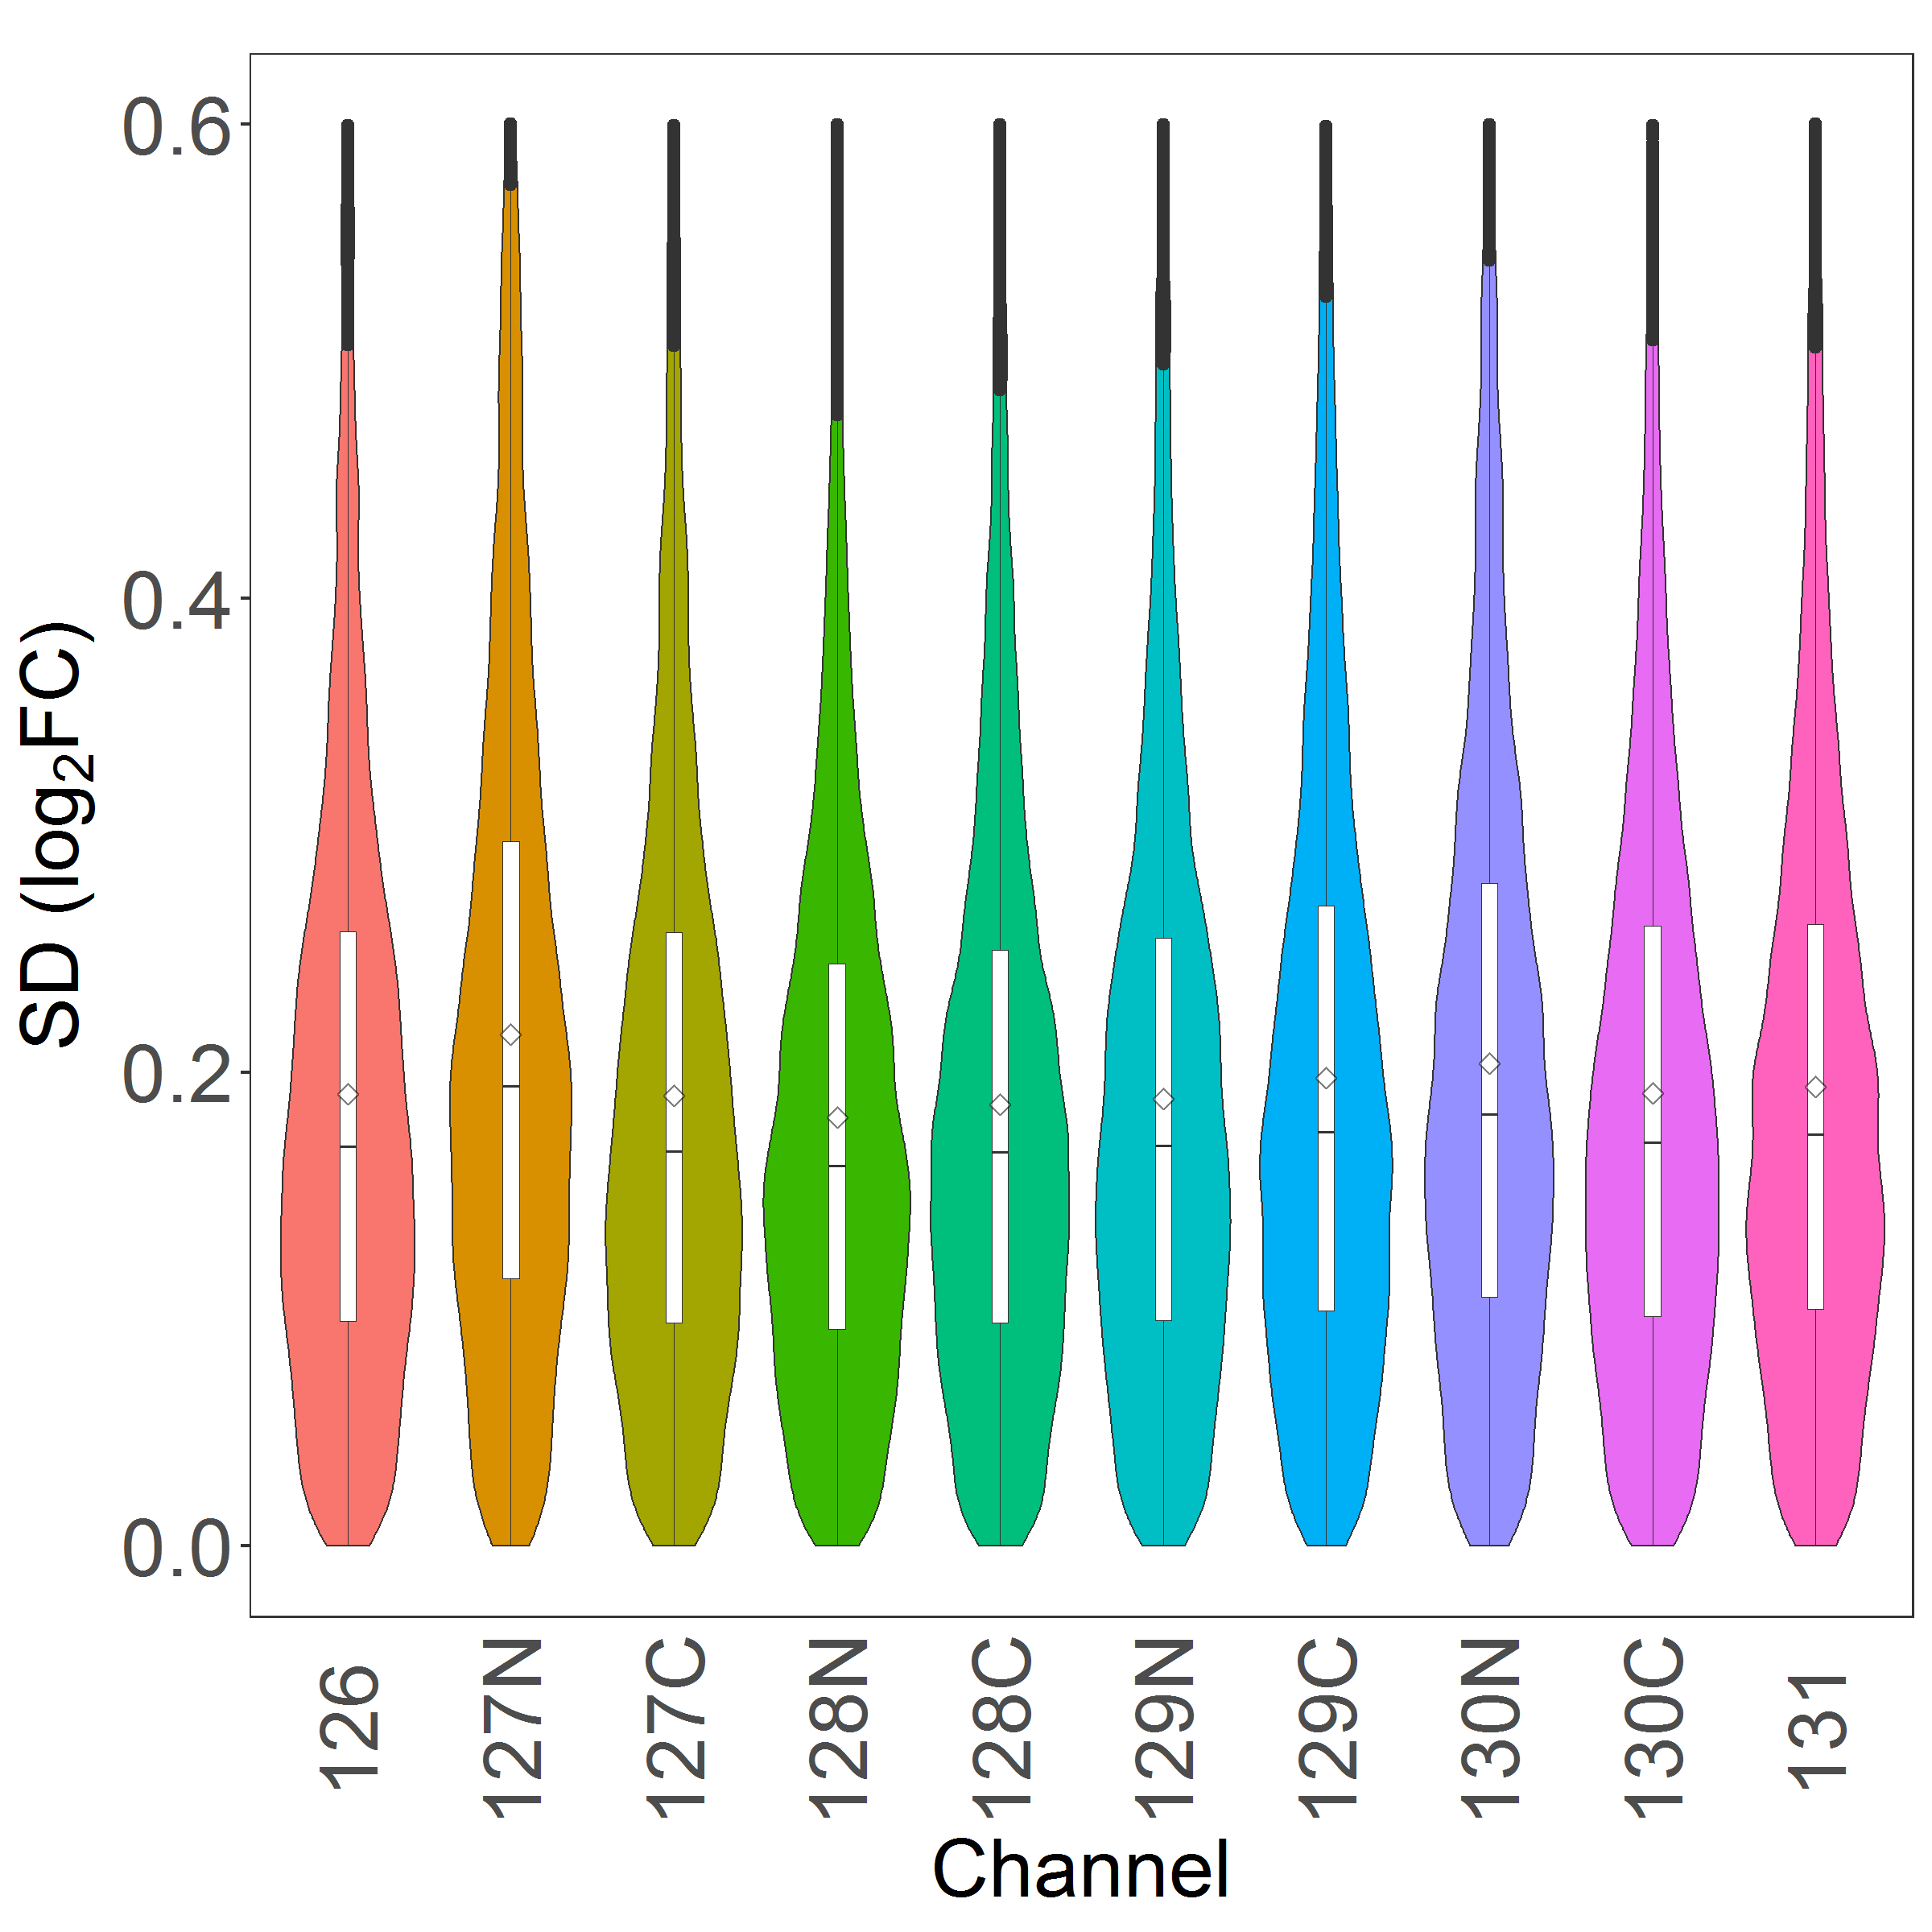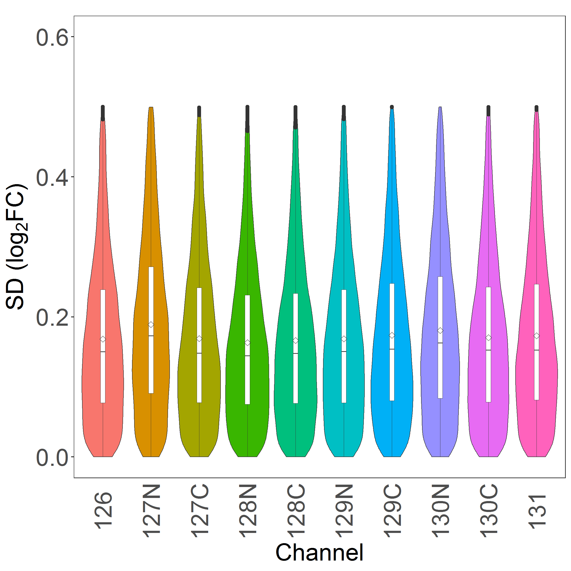

Quantitative differences greater than 0.5 at a log2 scale is big in TMT experiments, which can be largely ascribed to a phenomena called peptide co-isolation and co-fragmentation in MS experiments. We might, for instance, choose a CV cut-off at 0.5 as an additional step in data cleanup:

purgePSM (  
 max_cv = 0.5,  
)  
  
# equivalent to   
purgePSM (  
 max_cv = 0.5,  
 min_n = 2,  
)

Peptide quantitations with single PSM identification, so-called one-hit wonders, will yield infinite CV and be nullified as well.

*NB:* CV is sensitive to outliers and some large CV in peptide quantitations may be merely due to a small number of bad measures. Although the option of rm_outliers was set to FALSE during our earlier call to normPSM, I think it is generally a good idea to have rm_outliers = TRUE.

#### 1.2.2 Summarize PSMs to peptides

In this section, we summarise the PSM results to peptides with normPep and optional purgePep.

##### 1.2.2.1 normPep

The core utility for the summary of PSMs to peptides is normPep:

# peptide reports  
normPep(  
 # group_pep_by = gene, # depreciated  
 method_psm_pep = median,  
 method_align = MGKernel,  
 range_log2r = c(5, 95),  
 range_int = c(5, 95),  
 n_comp = 3,  
 seed = 749662,  
 maxit = 200,  
 epsilon = 1e-05,  
  
 filter_by = exprs(pep_n_psm >= 2),  
)

The log2FC of peptide data will be aligned by median centering across samples by default. If method_align = MGKernel is chosen, log2FC will be aligned under the assumption of multiple Gaussian kernels.[6] The parameter n_comp defines the number of Gaussian kernels and seed set a seed for reproducible fittings. The parameters range_log2r and range_int define the range of log2FC and the range of reporter-ion intensity, respectively, for use in the scaling of standard deviation across samples.

In the examplary vararg statement of filter_by, we set a threshold in the minimum number of identifying PSMs for peptides. If we are not interested in mouse peptides from the pdx samples, We can specify similarly that species == "human", or more precisely, species != "mouse". Sometimes, it may remain unclear on proper data filtration at the early stage of analysis. In that case, we may need additional quality assessments that we will soon explore. Alternatively, we may keep as much information as possible and apply varargs in downstream analysis. For more description of normPep, one can access its help document via ?normPep.

##### 1.2.2.2 purgePep

Analogously to the PSM processing, we may remove probable low-quality entries of proteins by specifying the maximum CV and the minimum number of peptide observations:

purgePep (  
 max_cv = 0.5,  
)  
  
# equivalent to   
purgePep (  
 max_cv = 0.5,  
 min_n = 2,  
)

We can use a vararg approach if the cut-offs in CV need to be sample specific:

normPep(  
 ...,  
 filter_by = exprs(pep_n_psm >= 2),  
 filter_by_2 = exprs(`sd_log2_R126 (W2.BI.TR1.TMT1)` <= .52,   
 `sd_log2_R130N (W16.PNNL.TR4.TMT2)` <= .48)  
)

Backticks were used here to embrace column keys containing white space(s) and/or special character(s) such as parenthesis.

##### 1.2.2.3 pepHist

We next compare the log2FC profiles with and without scaling normalization:[7]

# without scaling  
pepHist(  
 scale_log2r = FALSE,   
 ncol = 10,  
)  
  
# with scaling   
pepHist(  
 scale_log2r = TRUE,   
 ncol = 10,  
)

By default, the above calls will look for none void entries under column Select in expt_smry.xlsx. This will results in histogram plots with 60 panels in each, which may not be easy to explore as a whole. In stead, we will break the plots down by their data origins. We begin with modifying the expt_smry.xlsx file by adding the columns BI, JHU and PNNL. Each of the new columns includes sample entries that are tied to their laboratory origins (the columns are actually already in the expt_smry.xlsx).

[](https://www.youtube.com/embed/3B5et8VY3hE)

We now are ready to plot histograms for each subset of the data.[8] In this document, we only display the plots using the BI subset:

# without scaling   
pepHist(  
 scale_log2r = FALSE,   
 col_select = BI,  
 ncol = 5,  
 filename = Hist_BI_N.png,   
)  
  
# with scaling   
pepHist(  
 scale_log2r = TRUE,   
 col_select = BI,  
 ncol = 5,  
 filename = Hist_BI_Z.png,   
)

*NB*: We interactively told pepHist() that we are interested in sample entries under the newly created BI column. Behind the scene, the interactions are facilitated by [openxlsx](https://cran.r-project.org/web/packages/openxlsx/openxlsx.pdf) via the reading of the Setup workbook in expt_smry.xlsx. We also supply a file name, assuming that we want to keep the earlierly generated plots with default file names of Peptide_Histogram_N.png and Peptide_Histogram_Z.png.



As expected, the widths of log2FC profiles become more comparable after the scaling normalization. However, such adjustment may cause artifacts when the standard deviaiton across samples are genuinely different. I typically test scale_log2r at both TRUE and FALSE, then make a choice in data scaling together with my a priori knowledge of the characteristics of both samples and references.[9] We will use the same data set to illustrate the impacts of reference selections in scaling normalization in Lab 3.1. Alignment of log2FC against housekeeping or normalizer protein(s) is also available. This seems suitable when sometime the quantities of proteins of interest are different across samples where the assumption of constitutive expression for the vast majority of proteins may not hold.

It should also be noted that the curves of Gaussian density in histograms are based on the parameters from the latest call to normPep. There is a useful side effect when comparing leading and lagging profiles at different data filtration. This may aid the reveal of sample heteroscedasticity without the recourse to biological or technical replicates. More examples can be found from the help document via ?pepHist.

#### 1.2.3 Summarize peptides to proteins

In this section, we summarise peptides to proteins, for example, using a two-component Gaussian kernel and customized filters.

# protein reports  
normPrn(  
 method_pep_prn = median,   
 method_align = MGKernel,   
 range_log2r = c(20, 95),   
 range_int = c(5, 95),   
 n_comp = 2,   
 seed = 749662,   
 maxit = 200,   
 epsilon = 1e-05,   
   
 filter_by = exprs(prot_n_psm >= 3, prot_n_pep >= 2),   
)

Similar to the peptide summary, we inspect the alignment and the scaling of ratio profiles:

# without scaling  
prnHist(  
 scale_log2r = FALSE,   
 ncol = 10,  
 # filter_by = exprs(pep_n_psm >= 10),   
)  
  
# with scaling  
prnHist(  
 scale_log2r = TRUE,   
 ncol = 10,   
 # filter_by = exprs(pep_n_psm >= 10),   
)

*NB:* at this point, we might have reach a consensus on the choice of scaling normalization. If so, it may be plausible to set the value of scale_log2r under the Global environment, which is typically the R console that we are interacting with.

# if agree  
scale_log2r <- TRUE  
  
# or disagree  
scale_logr <- FALSE

In this way, we can skip the repetitive setting of scale_log2r in our workflow from this point on, and more importantly, prevent ourselves from peppering the values of TRUE or FALSE in scale_log2r from analysis to analysis.

### 1.3 Renormalize data for a subset of samples

A multi-Gaussian kernel can fail capturing the log2FC profiles for a subset of samples. This is less an issue with a small number of samples. Using a trial-and-error approach, we can start over with a new combination of parameters, such as a different seed, and/or a different range of scale_log2r et al. However, the one-size-fit-all attempt may remain inadequate when the number of samples is relatively large. The proteoQ allow users to *focus* fit aganist selected samples. This is the job of argument col_refit. Let’s say we want to re-fit the log2FC for samples W2.BI.TR2.TMT1 and W2.BI.TR2.TMT2. We simply add a column, which I named it Select_sub, to expt_smry.xlsx with the sample entries for re-fit being indicated under the column:



We then execute the following codes with argument col_refit being linked to the newly created column:

normPep(  
 method_psm_pep = median,   
 method_align = MGKernel,   
 range_log2r = c(5, 95),   
 range_int = c(5, 95),   
 n_comp = 3,   
 seed = 749662,   
 maxit = 200,   
 epsilon = 1e-05,   
   
 filter_by = exprs(prot_n_psm >= 2),  
 # filter_by_sp = exprs(species == "human"),   
 col_refit = Select_sub,  
)

### 1.4 Summarize MaxQuant results

In this section, we will process MaxQuant PSMs using the same set of data from CPTAC.

#### 1.4.1 MaxQuant PSM tables

The name of a PSM file containg reporter-ion intensities is msms.txt defaulted by MaxQuant. In the event of multiple msms.txt files for processing, the names need to be formatted in that they all start with msms and end with the .txt extension.

The file sizes of the msms.txt are relatively large for data used in the demonstration. For simplicity, we will only use the subset that belong to batch one in the CPTAC example. Even so, direct installation by devtools::install_github is not yet feasible at this point for large files hosted through [LFS](https://git-lfs.github.com/). One resort is to install [Github Desktop](https://desktop.github.com/), find <https://github.com/qiangzhang503/proteoQDB.git>, fetch the files and make a local installation through something like devtools::install(pkg = "~\\GitHub\\proteoQDB"). If all goes well with the local installation, we will load proteoQDB and copy over the PSM files therein to a working directory:

# fasta files to database directory  
library(proteoQDA)  
copy_refseq_hs("~\\proteoQ\\dbs\\fasta\\refseq")  
copy_refseq_mm("~\\proteoQ\\dbs\\fasta\\refseq")  
  
# examplary PSM data to working directory  
library(proteoQDB)  
dir.create("C:\\The\\MQ\\Example", recursive = TRUE, showWarnings = FALSE)  
dat_dir <- c("C:\\The\\MQ\\Example")  
cptac_mqpsm_txt(dat_dir)

Similarly, we copy over the corresponding expt_smry.xlsx and fract_smry.xlsx files and load the experiment:

# metadata to working directory  
cptac_mqpsm_expt(dat_dir)  
cptac_mqpsm_frac(dat_dir)  
  
# metadata upload  
library(proteoQ)  
load_expts()

We next process the PSM data from MaxQuant and perform peptide and protein normlizations. Note that some column keys in MaxQuant outputs contain white space(s) and special character(s) such as parenthesis. In these cases, we will need to quote the column keys with a pair of backticks when applying varargs for data filtration.

# PSM  
normPSM(  
 group_psm_by = pep_seq,   
 group_pep_by = gene,   
 fasta = c("~\\proteoQ\\dbs\\fasta\\refseq\\refseq_hs_2013_07.fasta",   
 "~\\proteoQ\\dbs\\fasta\\refseq\\refseq_mm_2013_07.fasta"),   
 rptr_intco = 3000,   
 corrected_int = TRUE,  
 rm_reverses = TRUE,  
 rm_craps = TRUE,  
 rm_krts = FALSE,  
 rm_outliers = FALSE,   
 annot_kinases = TRUE,   
 plot_rptr_int = TRUE,   
 plot_log2FC_cv = TRUE,   
   
 filter_peps = exprs(PEP <= 0.1),   
)  
  
# optional PSM purging  
purgePSM()  
  
# peptides  
normPep(  
 method_psm_pep = median,   
 method_align = MGKernel,   
 range_log2r = c(5, 95),   
 range_int = c(5, 95),   
 n_comp = 3,   
 seed = 749662,   
 maxit = 200,   
 epsilon = 1e-05,   
 # filter_by = exprs(pep_n_psm >= 2, species == "human"),  
)  
  
# optional peptide purging  
purgePep()  
  
# proteins  
normPrn(  
 use_unique_pep = TRUE,   
 method_pep_prn = median,   
 method_align = MGKernel,   
 range_log2r = c(20, 95),   
 range_int = c(5, 95),   
 n_comp = 2,   
 seed = 749662,   
 maxit = 200,   
 epsilon = 1e-05,   
 filter_by = exprs(prot_n_pep >= 2),  
)

Following the normalizations and cleanups, we can carry out analogous data visualization using the intensity-coded histograms. Note that I have renamed some column keys in the PSM, peptide and protein tables to match their counterparts in Mascot. The changes allow me to keep the code more succinct. I apologize if you find it all more difficult to deal with the new names.

### 1.5 Workflow scripts

Scripts that were used in this document can be accessed via:

system.file("extdata", "mascot_scripts.R", package = "proteoQ")  
system.file("extdata", "maxquant_scripts.R", package = "proteoQ")

## 2 Basic informatics

In this section I illustrate the following applications of proteoQ:

* Basic informatic analysis against peptide and protein data.
* Linear modeling using contrast fits

Unless otherwise mentioned, the in-function filtration of data by varargs of filter_ is available throughout this section of informatic analysis. Row ordering of data, indicated by arrange_, is available for heat map applications using pepHM and prnHM.

### 2.1 MDS and PCA plots

We first visualize MDS, PCA and Euclidean distance against the peptide data. We start with metric MDS for peptide data:

# all data  
pepMDS(  
 show_ids = FALSE,  
)



**Figure 3A.** MDS of peptide log2FC at scale_log2r = TRUE

It is clear that the WHIM2 and WHIM16 samples are well separated by the Euclidean distance of log2FC (**Figure 3A**). We next take the JHU data subset as an example to explore batch effects in the proteomic sample handling:

# `JHU` subset  
pepMDS(  
 col_select = JHU,  
 filename = MDS_JHU.png,  
 show_ids = FALSE,  
)



We immediately spot that all samples are coded with the same color (**Figure 3B**). This is not a surprise as the values under column expt_smry.xlsx::Color are exclusively JHU for the JHU subset. For similar reasons, the two different batches of TMT1 and TMT2 are distinguished by transparency, which is governed by column expt_smry.xlsx::Alpha. We may wish to modify the aesthetics using different keys: e.g., color coding by WHIMs and size coding by batches, without the recourse of writing new R scripts. One solution is to link the attributes and sample IDs by creating additional columns in expt_smry.xlsx. In this example, we have had coincidentally prepared the column Shape and Alpha to code WHIMs and batches, respectively, for the JHU subset. Therefore, we can recycle them directly to make a new plot (**Figure 3C**):

# new `JHU` subset  
pepMDS(  
 col_select = JHU,  
 col_fill = Shape, # WHIMs   
 col_size = Alpha, # batches  
 filename = MDS_JHU_new_aes.png,  
 show_ids = FALSE,  
)

Accordingly, the prnMDS performs MDS for protein data. For PCA analysis, the corresponding functions are pepPCA and prnPCA for peptide and protein data, respectively.

While MDS approximates Euclidean distances at a low dimensional space. Sometimes it may be useful to have an accurate view of the distance matrix. Functions pepEucDist and prnEucDist plot the heat maps of Euclidean distance matrix for peptides and proteins, respectively. They are wrappers of [pheatmap](https://cran.r-project.org/web/packages/pheatmap/pheatmap.pdf). Supposed that we are interested in visualizing the distance matrix for the JHU subset:

# `JHU` subset  
pepEucDist(  
 col_select = JHU,  
 annot_cols = c("Shape", "Alpha"),  
 annot_colnames = c("WHIM", "Batch"),   
   
 # `pheatmap` parameters   
 display_numbers = TRUE,   
 number_color = "grey30",   
 number_format = "%.1f",  
   
 clustering_distance_rows = "euclidean",   
 clustering_distance_cols = "euclidean",   
   
 fontsize = 16,   
 fontsize_row = 20,   
 fontsize_col = 20,   
 fontsize_number = 8,   
   
 cluster_rows = TRUE,  
 show_rownames = TRUE,  
 show_colnames = TRUE,  
 border_color = "grey60",   
 cellwidth = 24,   
 cellheight = 24,   
 width = 14,  
 height = 12,   
   
 filename = EucDist_JHU.png,  
)

Parameter annot_cols defines the tracks to be displayed on the top of distrance-matrix plots. In this example, we have choosen expt_smry.xlsx::Shape and expt_smry.xlsx::Alpha, which encodes the WHIM subtypes and the batch numbers, respectively. Parameter annot_colnames allows us to rename the tracks from Shape and Alpha to WHIM and Batch, respectively, for better intuition. We can alternatively add columns WHIM and Batch if we choose not to recycle and rename columns Shape and Alpha.



**Figure 3D.** EucDist of peptide log2FC at scale_log2r = TRUE

### 2.2 Correlation plots

In this section, we visualize the batch effects through correlation plots. The proteoQ tool currently limits itself to a maximum of 44 samples for a correlation plot. In the document, we will perform correlation analysis against the PNNL data subset. By default, samples will be arranged diagnoally from upper left to bottom right by the row order of expt_smry.xlsx::Select. We have learned from the earlier MDS analysis that the batch effects are smaller than the differences between W2 and W16. We may wish to put the TMT1 and TMT2 groups adjacient to each other for visualization of more nuance batch effects, followed by the comparison of WHIM subtypes. We can achieve this by supervising sample IDs at a customized order. In the expt_smry.xlsx, We have prepared an Order column where samples within the JHU subset were arranged in the descending order of W2.TMT1, W2.TMT2, W16.TMT1 and W16.TMT2. Now we tell the program to look for the Order column for sample arrangement:

# peptide logFC  
pepCorr_logFC(  
 col_select = PNNL,  
 col_order = Order,   
 filename = PNNL_pep_logfc.png,  
)  
  
# protein logFC  
prnCorr_logFC(  
 col_select = W2,  
 col_order = Group,  
 filename = PNNL_prn_logfc.png,  
)



To visualize the correlation of intensity data, we can use pepCorr_logInt and prnCorr_logInt for peptide and protein data, respectively. More details can be assessed via ?pepCorr_logFC.

### 2.3 Heat maps

Heat map visualization is commonly applied in data sciences. The corresponding facilities in proteoQ are pepHM and prnHM for peptide and protein data, respectively. They are wrappers of [pheatmap](https://cran.r-project.org/web/packages/pheatmap/pheatmap.pdf) with modifications and exception handlings. More details can be found by accessing the help document via ?prnHM.

The following shows an example of protein heat map:

prnHM(  
 xmin = -1,   
 xmax = 1,   
 x_margin = 0.1,   
 annot_cols = c("Group", "Color", "Alpha", "Shape"),   
 annot_colnames = c("Group", "Lab", "Batch", "WHIM"),   
 cluster_rows = TRUE,   
 cutree_rows = 10,   
 show_rownames = FALSE,   
 show_colnames = TRUE,   
 fontsize_row = 3,   
 cellwidth = 14,   
 width = 18,   
 height = 12,   
 filter_sp = exprs(species == "human"),  
)

we chose to top annotate the heat map with the metadata that can be found under the columns of Group, Color, Alpha and Shape in expt_smary.xlsx. For better convention, we rename them to Group, Lab, Batch and WHIM to reflect their sample characteristics. We further supplied a vararg of filter_sp where we assume exclusive interests in human proteins.



**Figure 5A.** Heat map visualization of protein log2FC

Row ordering of data is also implemented in the heat map utility.

prnHM(  
 xmin = -1,   
 xmax = 1,   
 x_margin = 0.1,   
 annot_cols = c("Group", "Color", "Alpha", "Shape"),   
 annot_colnames = c("Group", "Lab", "Batch", "WHIM"),   
 cluster_rows = FALSE,   
 annot_rows = c("kin_class"),   
 show_rownames = TRUE,   
 show_colnames = TRUE,   
 fontsize_row = 2,   
 cellheight = 2,   
 cellwidth = 14,   
 width = 16,   
 height = 11,   
 filter_kin = exprs(kin_attr == TRUE, species == "human"),  
 arrange_kin = exprs(kin_order, gene),  
 filename = "hukin_by_class.png",   
)

In the above example, we applied vararg filter_kin to subset human kinases from the protein data set by values under its kin_attr and the species columns. We further row annotate the heat map with argument annot_rows, which will look for values under the kin_class column. With the vararg, arrange_kin, we supervise the row ordering of kinases by values under the kin_order column and then those under the gene column. Analogous to the user-supplied filter_ arguments, the row ordering varargs need to start with arrange_ to indicate the task of row ordering.



**Figure 5B.** Heat map visualization of kinase log2FC

### 2.4 Significance tests and volcano plot visualization

In this section, we perform the significance analysis of protein data. The approach of contrast fit (Chambers, J. M. Linear models, 1992; Gordon Smyth et al., limma) is taken in proteoQ. We will first define the contrast groups for significance tests. For this purpose, I have devided the samples by their WHIM subtypes, laboratory locations and batch numbers. This ends up with entries of W2.BI.TMT1, W2.BI.TMT2 etc. under the expt_smry.xlsx::Term column. The interactive environment between the Excel file and the proteoQ tool allows us to enter more columns of contrasts when needed. For instance, we might also be interested in a more course comparison of inter-laboratory differences without batch effects. The corresponding contrasts of W2.BI, W2.BI etc. can be found under a pre-made column, Term_2. Having these columns in hand, we next perform significance tests and data visualization for protein data:

# significance tests  
prnSig(  
 impute_na = FALSE,   
 W2_bat = ~ Term["W2.BI.TMT2-W2.BI.TMT1", "W2.JHU.TMT2-W2.JHU.TMT1", "W2.PNNL.TMT2-W2.PNNL.TMT1"], # batches  
 W2_loc = ~ Term_2["W2.BI-W2.JHU", "W2.BI-W2.PNNL", "W2.JHU-W2.PNNL"], # locations  
)  
  
# volcano plots  
prnVol()

Note that we have informed the prnSig utility to look for contrasts under columns Term and Term_2, followed by the cotrast pairs in square brackets. Pairs of contrasts are separated by commas.

The prnVol utility will by default match the formulae of contrasts with those in prnSig; the same is true for peptide analysis. The following plots show the batch difference between two TMT experiments for each of the three laboratories and the location difference between any two laboratories.



In general, the special characters of + and - in contrast terms need to be avoided in linear modeling. However, it may be sporadically convenient to use A+B to denote a combined treatment of both A and B. In the case, we will put the term(s) containing + or - into a pair of pointy brackets. The syntax in the following hypothetical example will compare the effects of A, B, A+B and the average of A and B to control C.

# note that <A + B> is one condition whereas (A + B) contains two conditions  
prnSig(  
 fml = ~ Term["A - C", "B - C", "<A + B> - C", "(A + B)/2 - C"],  
)

In addition to the fixed effects shown above, significance tests with additive random effects are also supported. Analogous to protein data, peptide data can be analyzed and visualized with pepSig and pepVol. More examples can be found via ?prnSig and Lab 3.3 in the document.

### 2.5 Gene sets under volcano plots

There are a handful of R tools for gene set enrichement analysis, such as GSEA, GSVA, gage, to name a few. It may be intuitive as well if we can visualize the enrichment of gene sets under the context of volcano plots at given contrasts. Provided the richness of R utilities in linear modelings, the preoteoQ takes a naive approach thereafter to visualize the *asymmetricity* of protein probability *p*-values under volcano plots. In the analysis of Gene Set Probability Asymmetricity (GSPA), the significance pVals of proteins obtained from linear modeling are taken, followed by the calculation of the geometric mean of pVals for the groups of up- or down-regulated proteins within a gene set, as well as the corresponding mean log2FC. The quotient of the two pVals is then taken to represent the significance of enrichment, and the delta of the two log2FC for use as the fold change of enrichment. The arguments pval_cutoff and logFC_cutoff allow us to filter out low impact genes prior to the analysis. More details can be found from the help document via ?prnGSPA. Note that there is no peptide counterpart for the enrichment analysis.

We began with the analysis of GSPA against enrichment terms defined in GO and KEGG data sets:

prnGSPA(  
 impute_na = FALSE,  
 pval_cutoff = 5E-2,  
 logFC_cutoff = log2(1.2),  
 gset_nms = c("go_sets", "kegg_sets"),  
)

The formulae of contrasts will by default match to the those used in prnSig. The species will be determined automatically from input data and the corresponding databases will be loaded. In the above example of pdx, databases of GO and KEGG will be loaded for both human and mouse. If we choose to focus on human proteins, we can add a vararg statement such as filter_sp = exprs(species == "human").

We next visualize the distribution of protein log2FC and pVal within gene sets:

gspaMap(  
 show_labels = TRUE,  
 pval_cutoff = 5E-3,  
 logFC_cutoff = log2(1.2),  
 gset_nms = c("go_sets"),  
 show_sig = p,  
 yco = 0.01,  
)

This will produce the volcano plots of proteins under gene sets that have passed our selection criteria. Here, we show one of the examples:



**Figure 7.** An example of volcano plots of protein log2FC under a gene set

The list of gene sets will by default match those provided in prnGSPA. Despite in the above example, we chose to plot the results against gene sets in GO, not KEGG. More details can be accessed from the help document via ?gspaMap.

### 2.6 Trend Analysis

The following performs the trend analysis against protein expressions. More information can be found from [Mfuzz](https://www.bioconductor.org/packages/release/bioc/vignettes/Mfuzz/inst/doc/Mfuzz.pdf) and ?anal_prnTrend. Note that the number of clusters is provided by n_clust, which can be a single value or a vector of integers.

# soft clustering of protein expression data  
anal_prnTrend(  
 col_order = Order,  
 n_clust = c(5:8),   
   
 filter_by_npep = exprs(prot_n_pep >= 2),  
)  
  
# visualization  
plot_prnTrend(  
 col_order = Order,  
 n_clust = 6,   
   
 filter_by_npep = exprs(prot_n_pep >= 4),  
)

The argument col_order provides a means to supervise the order of samples in result tables or during the trend visualization. In the above example, the anal_prnTrend and plot_prnTrend will both look into the field under the expt_smry.xlsx::Order column for sample arrangement. At n_clust = 6, the correspondence between protein IDs and their cluster assignments is summarised in file Protein_Trend_Z_n6.csv. The letter Z in the file name denotes the option of scale_log2r = TRUE.



**Figure 8.** Trend analysis of protein log2FC.

### 2.7 NMF Analysis

The following performs the NMF analysis against protein data. More details can be found from [NMF](https://cran.r-project.org/web/packages/NMF/vignettes/NMF-vignette.pdf) and anal_prnNMF.

# load library  
library(NMF)  
  
# NMF analysis  
anal_prnNMF(  
 impute_na = FALSE,  
 col_group = Group, # optional a priori knowledge of sample groups  
 r = c(5:8),  
 nrun = 200,   
 filter_by_npep = exprs(prot_n_pep >= 2),  
)  
  
# consensus heat map  
plot_prnNMFCon(  
 impute_na = FALSE,  
 annot_cols = c("Color", "Alpha", "Shape"),  
 annot_colnames = c("Lab", "Batch", "WHIM"),  
 width = 10,  
 height = 10,   
)  
  
  
# coefficient heat map  
plot_prnNMFCoef(  
 impute_na = FALSE,  
 r = 6,   
 annot_cols = c("Color", "Alpha", "Shape"),   
 annot_colnames = c("Lab", "Batch", "WHIM"),   
 width = 10,   
 height = 10,   
)  
  
# metagene heat map(s)  
plot_metaNMF(  
 impute_na = FALSE,  
 r = 6,   
 annot_cols = c("Color", "Alpha", "Shape"),   
 annot_colnames = c("Lab", "Batch", "WHIM"),   
   
 fontsize = 8,   
 fontsize_col = 5,  
)



### 2.8 STRING Analysis

The following performs the [STRING](http://www.string-db.org) analysis of protein-protein interactions. More details can be found from ?getStringDB.

getStringDB(  
 db_path = "~\\proteoQ\\dbs\\string",  
 score_cutoff = .9,  
 nseq_cutoff = 2,  
 adjP = FALSE,   
)

The results of protein-protein interaction is summarised in Protein_STRING_ppi.tsv and the expression data in Protein_STRING_expr.tsv. The files are formatted for direct applications with [Cytoscape](https://cytoscape.org). When calling getStringDB, the corresponding databases will be downloaded automatically if not yet present locally. One can also choose to download separately the databases for a given species:

dl_stringdbs(  
 species = rat,  
 db_path = "~\\proteoQ\\dbs\\string",   
)

### 2.9 Missing value imputation

Imputation of peptide and protein data are handle with pepImp and prnImp. More information can be found from [mice](https://cran.r-project.org/web/packages/mice/mice.pdf) and ?prnImp.

## 3 Labs

### 3.1 Reference choices

In this lab, we explore the effects of reference choices on data normalization. We first copy data over to the file directory specified by temp_dir, followed by PSM, peptide normalization and histogram visualization of peptide log2FC.

# directory setup  
dir.create("C:\\The\\W2_ref\\Example", recursive = TRUE, showWarnings = FALSE)  
temp_dir <- "c:\\The\\W2_ref\\Example"  
library(proteoQDA)  
cptac_csv_1(temp_dir)  
cptac_expt_ref_w2(temp_dir)  
cptac_frac_1(temp_dir)  
  
# analysis  
library(proteoQ)  
load_expts(temp_dir, expt_smry_ref_w2.xlsx)  
  
normPSM(  
 group_psm_by = pep_seq,  
 group_pep_by = gene,   
 fasta = c("~\\proteoQ\\dbs\\fasta\\refseq\\refseq_hs_2013_07.fasta",   
 "~\\proteoQ\\dbs\\fasta\\refseq\\refseq_mm_2013_07.fasta"),   
 rptr_intco = 3000,  
 rm_craps = TRUE,  
 rm_krts = FALSE,  
 rm_outliers = FALSE,   
 annot_kinases = TRUE,   
 plot_rptr_int = TRUE,   
 plot_log2FC_cv = TRUE,   
   
 filter_peps = exprs(pep_expect <= .1),   
)  
  
normPep(  
 method_psm_pep = median,   
 method_align = MGKernel,   
 range_log2r = c(5, 95),   
 range_int = c(5, 95),   
 n_comp = 3,   
 seed = 749662,   
 maxit = 200,   
 epsilon = 1e-05,   
)  
  
# visualization  
pepHist(  
 scale_log2r = FALSE,   
 ncol = 9,  
)

Notice that in the histograms the log2FC profiles of WHIM2 samples are much narrower than those of WHIM16 (**Figure S1A**). This will occur when a reference is more similar to one group of sample(s) than the other. In our case, the reference is one of WHIM2. The difference in the breadth of log2FC profiles between the WHIM16 and the WHIM2 groups is likely due to the genuine difference in their proteomes. If the above argument is valid, a scaling normalize would moderate, and thus bias, the quantitative difference in proteomes between WHIM2 and WHIM16.



**Figure S1A.** Histograms of peptide log2FC with a WHIM2 reference.

We alternatively seek a “center-of-mass” representation for uses as references. We select one WHIM2 and one WHIM16 from each 10-plex TMT. The proteoQ tool will average the signals from designated references. Thefore, the derived reference can be viewed as a mid point of the WHIM2 and the WHIM16 proteomes. We next perform analogously the data summary and histogram visualization.

# directory setup  
dir.create("C:\\The\\W2_W16_ref\\Example", recursive = TRUE, showWarnings = FALSE)  
temp_dir_2 <- "c:\\The\\W2_W16_ref\\Example"  
library(proteoQDA)  
cptac_csv_1(temp_dir_2)  
expt_smry_ref_w2_w16(temp_dir_2)  
cptac_frac_1(temp_dir_2)  
  
# experiment upload  
library(proteoQ)  
load_expts(temp_dir_2, expt_smry_ref_w2_w16.xlsx)  
  
# PSM normalization  
normPSM(  
 group_psm_by = pep_seq,  
 group_pep_by = gene,   
 fasta = c("~\\proteoQ\\dbs\\fasta\\refseq\\refseq_hs_2013_07.fasta",   
 "~\\proteoQ\\dbs\\fasta\\refseq\\refseq_mm_2013_07.fasta"),   
 rptr_intco = 3000,  
 rm_craps = TRUE,  
 rm_krts = FALSE,  
 rm_outliers = FALSE,   
 annot_kinases = TRUE,   
 plot_rptr_int = TRUE,   
 plot_log2FC_cv = TRUE,   
   
 filter_peps = exprs(pep_expect <= .1),   
)  
  
# peptide normalization  
normPep(  
 method_psm_pep = median,   
 method_align = MGKernel,   
 range_log2r = c(5, 95),   
 range_int = c(5, 95),   
 n_comp = 3,   
 seed = 749662,   
 maxit = 200,   
 epsilon = 1e-05,   
)  
  
# visualization  
pepHist(  
 scale_log2r = FALSE,   
 ncol = 8,  
)

With the new reference, we have achieved log2FC profiles that are more comparable in breadth between WHIM2 and WHIM16 samples and a scaling normalization seems more suitable.



**Figure S1B.** Histograms of peptide log2FC with a combined WHIM2 and WHIM16 reference.

### 3.2 Peptide subsets

In addition to the global proteomes, the CPTAC publication contains phosphopeptide data from the same samples.(2018) In this lab, we will explore the stoichiometry of phosphopeptide subsets in relative to the combined data sets of global + phospho peptides. We first performed a search aganist the combined data. The search results are available in proteoQDA. We next copy the result files over, followed by the analysis and visualization of the BI subset:

# directory setup  
temp_phospho_dir <- "c:\\The\\Phosphopeptide\\Example"  
library(proteoQDA)  
cptac_csv_2(temp_phospho_dir)  
cptac_expt_2(temp_phospho_dir)  
cptac_frac_2(temp_phospho_dir)  
  
# experiment upload  
library(proteoQ)  
load_expts(temp_phospho_dir, expt_smry.xlsx)  
  
# PSM normalization  
normPSM(  
 group_psm_by = pep_seq_mod,  
 group_pep_by = gene,   
 fasta = c("~\\proteoQ\\dbs\\fasta\\refseq\\refseq_hs_2013_07.fasta",   
 "~\\proteoQ\\dbs\\fasta\\refseq\\refseq_mm_2013_07.fasta"),   
 rptr_intco = 3000,  
 rm_craps = TRUE,  
 rm_krts = FALSE,  
 rm_outliers = FALSE,   
 annot_kinases = TRUE,   
 plot_rptr_int = TRUE,   
 plot_log2FC_cv = TRUE,   
   
 filter_peps = exprs(pep_expect <= .1),   
)  
  
# peptide normalization  
normPep(  
 method_psm_pep = median,   
 method_align = MGKernel,   
 range_log2r = c(5, 95),   
 range_int = c(5, 95),   
 n_comp = 3,   
 seed = 749662,   
 maxit = 200,   
 epsilon = 1e-05,   
)  
  
# histograms for all peptides  
pepHist(  
 col_select = BI,   
 scale_log2r = TRUE,   
 ncol = 4,   
 filename = "BI_all_peptides.png",  
)  
  
# histograms for phosphopeptide subsets  
pepHist(  
 col_select = BI,   
 scale_log2r = TRUE,   
 pep_pattern = "sty",   
 ncol = 4,   
 filename = "BI_pSTY.png",  
)

Ideally, the profiles of the log2FC between the phospho subsets and the overall data would either align at the maximum density or perhaps offset by similar distance among replicated samples. In this example, the alginment at maximum density seems to be case. The observation raises the possibility of measuring the stoichiometry of phosphoproteomes in relative to global data across sample types or conditions.

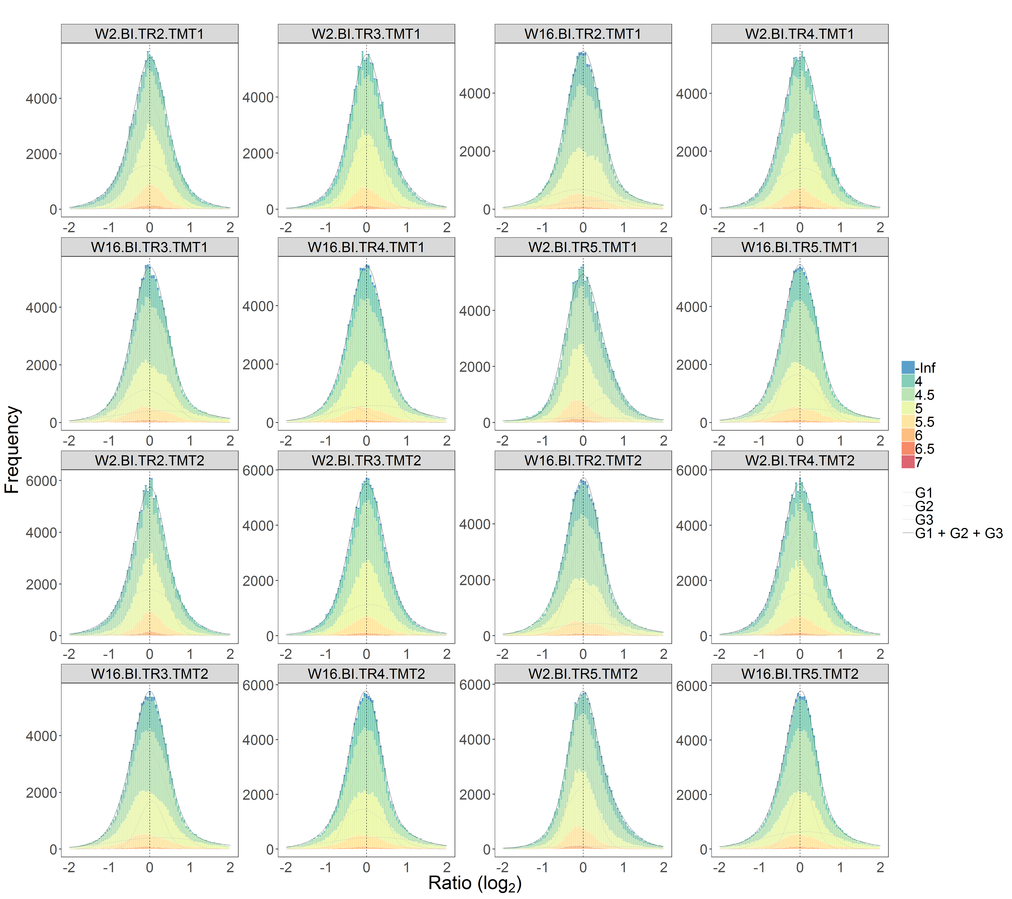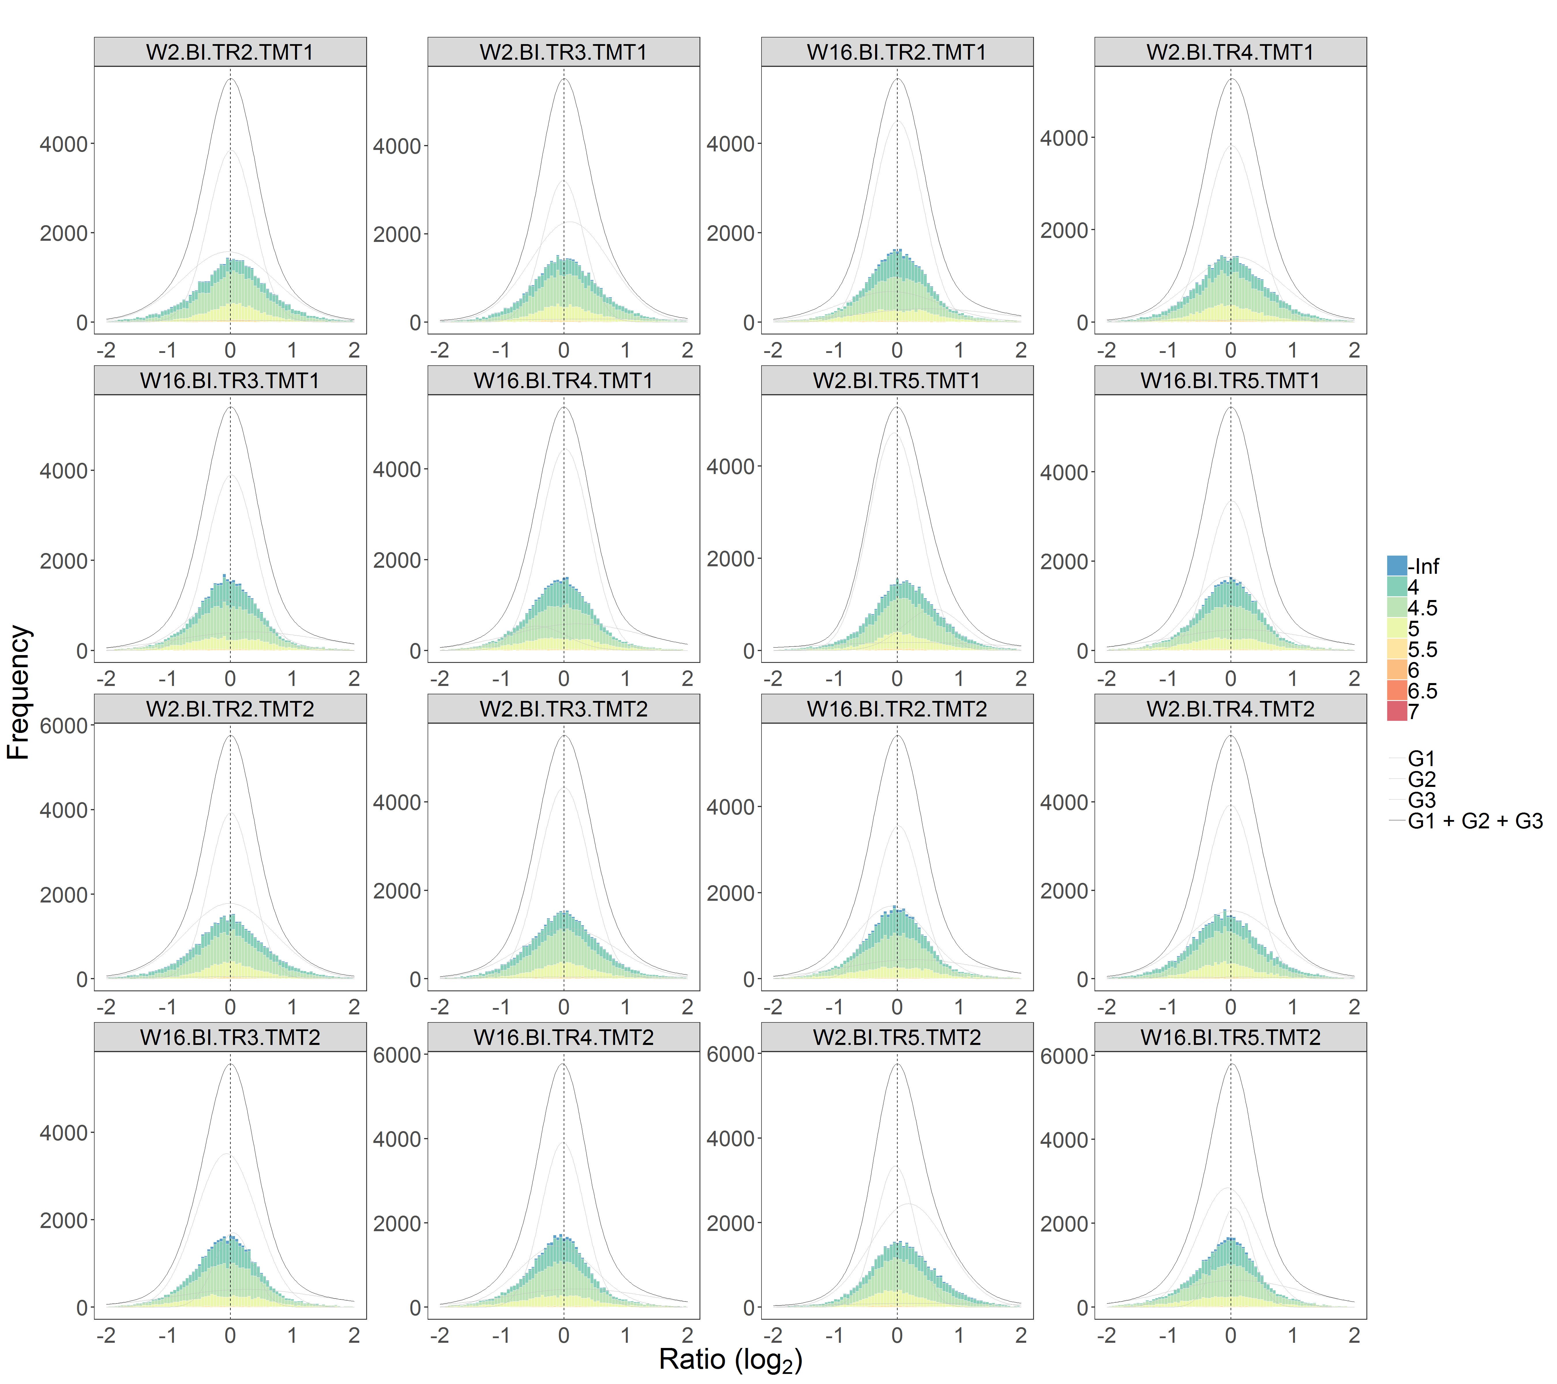

### 3.3 Random effects

Models that incorporate both fixed- and random-effects terms in a linear predictor expression are often termed mixed effects models.

#### 3.3.1 Single random effect

In proteomic studies involved multiple multiplex TMT experiments, the limited multiplicity of isobaric tags requires sample parting into subgroups. Measures in log2FC are then obtained within each subgroup by comparing to common reference materials, followed by data bridging across experiments. This setup violates the independence assumption in statistical sampling as the measures of log2FC are batched by TMT experiments. In this lab, we will use the CPTAC data to test the statistical significance in protein abundance between the WHIM2 and the WHIM16 subtypes, by first taking the batch effects into account. We will use mixed-effects models to explore the random effects that were introduced by the data stitching. In case that you would like to find out more about mixed-effects models in R, I found the online [tutorial](http://www.bodowinter.com/tutorial/bw_LME_tutorial2.pdf) a helpful resource.

We start off by copying over the expt_smry.xlsx file, which contains a newly created column, Term_3, for terms to be used in the statistical tests of WHIM2 and WHIM16. We also copy over the protein results from Section 1 of the vignette and carry out the signficance tests with and without random effects.

# directory setup  
temp_raneff_dir <- "c:\\The\\Random_effects\\Example"  
library(proteoQDA)  
cptac_prn_1(temp_raneff_dir)  
cptac_expt_3(temp_raneff_dir)  
cptac_frac_3(temp_raneff_dir)  
  
# analysis  
library(proteoQ)  
load_expts(temp_raneff_dir, expt_smry.xlsx)  
  
prnSig(  
 impute_na = FALSE,   
 W2_vs_W16_fix = ~ Term_3["W16-W2"], # fixed effect only  
 W2_vs_W16_mix = ~ Term_3["W16-W2"] + (1|TMT_Set), # one fixed and one random effects  
)  
  
# volcano plots  
prnVol()

In the formula linked to argument W2_vs_W16_mix, the random effect (1|TMT_Set) is an addition to the fix effect Term_3["W16-W2"]. The syntax (1|TMT_Set) indicates the TMT_Set term to be parsed as a random effect. The name of the term is again a column key in expt_smry.xlsx. In this example, the TMT batches are documented under the column TMT_Set and can be applied directly to our formula. Upon the completion of the protein signficance tests, we can analyze analogously the gene set enrichment against these new formulas by calling functions prnGSPA and gspaMAP.

#### 3.3.2 Multiple random effects

In this section, we will test the statistical significance in protein abundance changes between the WHIM2 and the WHIM16 subtypes, by taking additively both the TMT batch effects and the laboratory effects into account. At the time of writing the document, I don’t yet know how to handle multiple random effects using limma. Alternatively, I use lmerTest to do the work.

Missing values can frequently fail random-effects modeling with more complex error structures and need additional cares. One workaround is to simply restrict ourselves to entries that are complete in cases. This would lead to a number of proteins not measurable in their statistical significance. Alternatively, we may seek to fill in missing values using techniques such as multivariate imputation.

We further note that the laboratory differences are coded under columns Color in expt_smry.xlsx. We then test the statistical difference between WHIM2 and WHIM16 against the following three models:

# impute NA  
prnImp(m = 5, maxit = 5)  
  
# significance tests  
prnSig(  
 impute_na = TRUE,  
 method = lm,  
 W2_vs_W16_fix = ~ Term_3["W16-W2"], # one fixed effect  
 W2_vs_W16_mix = ~ Term_3["W16-W2"] + (1|TMT_Set), # one fixed and one random effect  
 W2_vs_W16_mix_2 = ~ Term_3["W16-W2"] + (1|TMT_Set) + (1|Color), # one fixed and two random effects  
)  
  
# correlation plots  
read.csv(file.path(temp_raneff_dir, "Protein\\Model\\Protein_pVals.txt"),   
 check.names = FALSE, header = TRUE, sep = "\t") %>%  
 dplyr::select(grep("pVal\\s+", names(.))) %>%   
 `colnames<-`(c("none", "one", "two")) %>%   
 dplyr::mutate_all(~ -log10(.x)) %>%   
 GGally::ggpairs(columnLabels = as.character(names(.)), labeller = label_wrap_gen(10), title = "",   
 xlab = expression("pVal ("*-log[10]*")"), ylab = expression("pVal ("*-log[10]*")"))

The correlation plots indicate that the random effects of batches and laboratory locations are much smaller than the fixed effect of the biological differences of WHIM2 and WHIM16.



**Figure S3.** Pearson r of protein significance p-values.

## References

Philipp, Martins. 2018. “Reproducible Workflow for Multiplexed Deep-Scale Proteome and Phosphoproteome Analysis of Tumor Tissues by Liquid Chromatography-Mass Spectrometry.” *Nature Protocols* 13 (7): 1632–61. <https://doi.org/10.1038/s41596-018-0006-9>.

Wickham, Hadley. 2019. *Advanced R*. 2nd ed. Chapman & Hall/CRC. <https://adv-r.hadley.nz/>.

1. The default file names begin with letter F, followed by six digits and ends with .csv in name extension.
2. There are cases that the same peptide sequence being assigned to different proteins remain unambiguous. For example, peptide MENGQSTAAK can be found from both the middle region of proteins NP_510965 and the N-terminal of protein NP_001129505. In case of the additional information of peptide N-terminal acetylation, the sequence can only come from NP_001129505 between the two candidate proteins. In addition to handling such exceptions, the nomenclature in proteoQ will annotate the former as K.MENGQSTAAK.L and the later as -._MENGQSTAAK.L.
3. To extract the names of RAW MS files under a raw_dir folder: extract_raws(raw_dir). Very occasionally, there may be RAW files without PSM contributions. In this case, the file names will be shown as missing by the program and need to be removed from expt_smry.xlsx or frac_smry.xlsx. The function extract_psm_raws(dat_dir) was developed to extract the list of RAW files that are actually present in PSM files.
4. The sample removal and PSM re-processing can be achieved by deleting the corresponding entries under the column Sample_ID in expt_smry.xlsx, followed by the re-execution of normPSM().
5. A pseudonym approach used in Tidyverse, such as starts_with, contains may be easier to work with for logical conditions and need implementation.
6. Density kernel estimates can occasionally capture spikes in the profiles of log2FC during data alignment. Users will need to inspect the alignment of ratio histograms and may optimize the data normalization in full with different combinations of tuning parameters or in part against a subset of samples, before proceeding to the next steps.
7. normPep() will report log2FC results both before and after the scaling of standard deviations.
8. System parameters will be automatically updated from the modified expt_smry.xlsx
9. The default is scale_log2r = TRUE throughout the package. When calling functions involved parameter scale_log2r, users can specify explicitly scale_log2r = FALSE or define its value under the global environment.